# Department of Computing

**SE312: Software Construction**

**Class: BESE – 5 B**

# Assignment 3

# Point of Sale System

**Date: May 21st, 2017**

Group Members:

Faizan Zafar (111528)

Shoaib Sarwar (111416)

Bilal Ahmad (111445)

# 

**Introduction**

The task of the assignment is to build an enterprise application for managing the POS operations for a new café in Islamabad. The café is expanding to 3 branches. To tackle the business needs of the café, we have built a web application. It caters to the needs of the administrator, employee and customer and provides basic functionalities that are present in POS systems worldwide i.e. inventory management, employee management, customer management, sales reporting. The web application keeps track of the sales made in some duration and provides a high level view in the form of sales report. The admin can manage employees and generate the sales report. The employee, cashier in our case, can handle the operations of the customer and product inventory. The customer can enter items from a menu. The application uses a clear GUI with well-defined graphic elements.

**Novelty in approach**

The application uses different coding practices to implement the web application. We have used separation of concerns and implemented functionalities in separate files. We have chosen web because it is widely accepted and users are mostly familiar with it. The technologies we have used is HTML, CSS, JS, jQuery as part of front end and PHP with MySQL for database management as part of back end. The reason for choosing PHP is that it provides much customizations over functionalities. We have learnt that these technologies offer simplicity in the design and can manage the data efficiently. This is what is required for a functional POS system.

**How to run application**

The web application requires installation of wamp and any browser on PC. It is not hosted on an online server so we are using local server. Copy the POS folder containing all the files of the application into the C:/wamp/www directory of wamp installation. Then run the browser and enter localhost/POS into the address bar and press enter. The website should display login page and following credentials can be entered to gain access.

For admin:

Username: admin

Password: admin

For employee:

Username: employee

Password: employee

For customer:

Username: customer

Password: customer

**Sample runs**

1. After following the steps of how to run the application, we visit the first web page. It displays a mini-form asking for username. The admin, employee, customer login from their respective credentials.

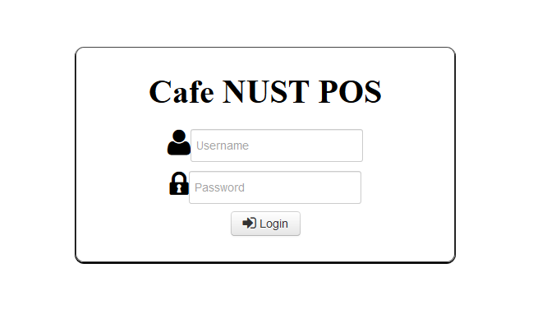

1. For the admin panel, login is successful and following interface appears. Admin can manage employees and view sales report for a specific period of time.

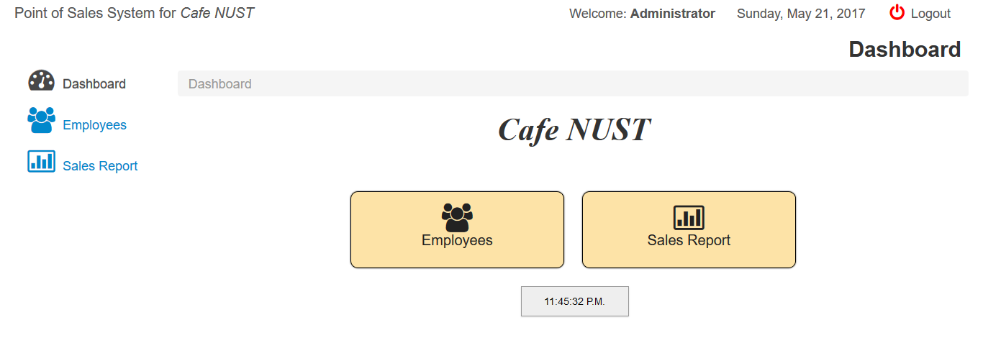

1. The employee management module allows for different operations with the data of the employees. Sample run shows successful entering and display of data.

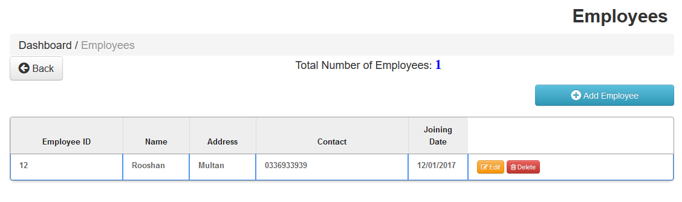

1. The employee panel is accessed by employees’ login. Employee is able to manage data of customers and products.

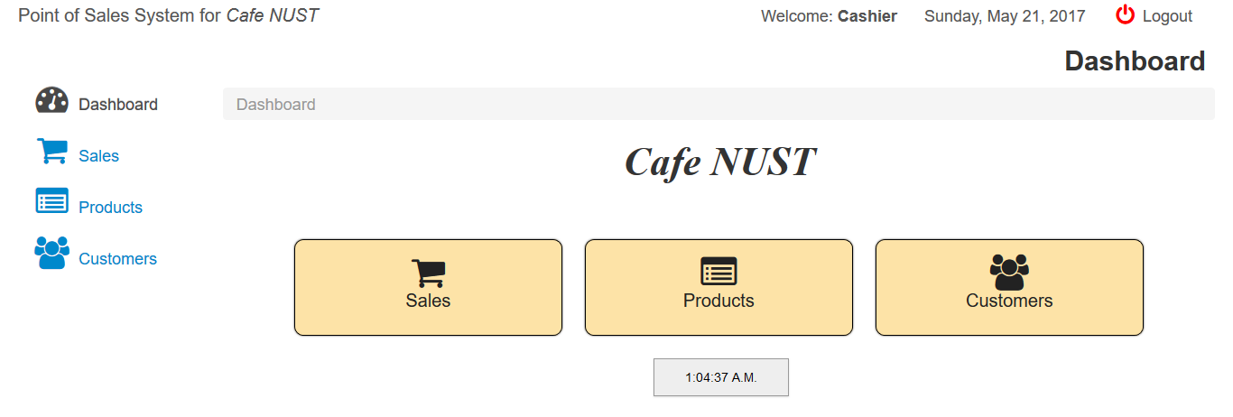

1. The customer management module allows for different operations with the data of the customers. Sample run shows successful entering and display of data.

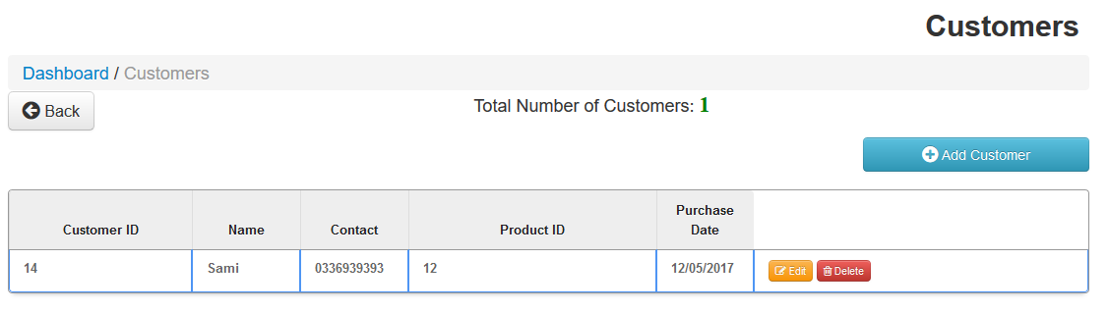

1. The product inventory module of the application allows for entering and manipulating data related to products. Business logic of profits and quantity of products remaining is applied in this web page. Sample run shows successful product entry.

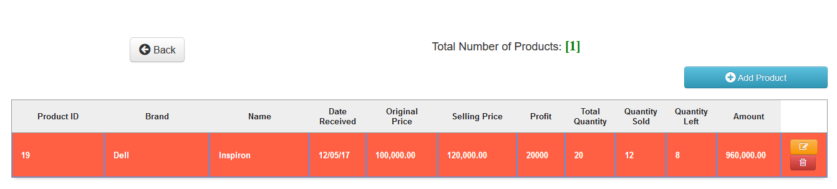

**Github Link:**

[**https://github.com/faizanzafar95/SE312-Assignment3**](https://github.com/faizanzafar95/SE312-Assignment3)